GOOGLE SEARCH CONSOLE ANALYSIS REPORT
Website: https://ben10.liveblog365.com/
Platform: Wordpress
Date: February 2026

1. Introduction
This project analyze the website ben10.liveblog365.com using Google Search Console (GSC).
Google Search Console helps website owners monitor and improve their presence in Google Search results.

2. Performance Report Analysis

Observation:
- No clicks recorded.
- No impressions recorded.
- No CTR or average position data.
Reason:
The website is new and has not yet started ranking in Google Search results.
Conclusion:
More time, content improvement, and proper SEO strategies are required to generate search traffic.

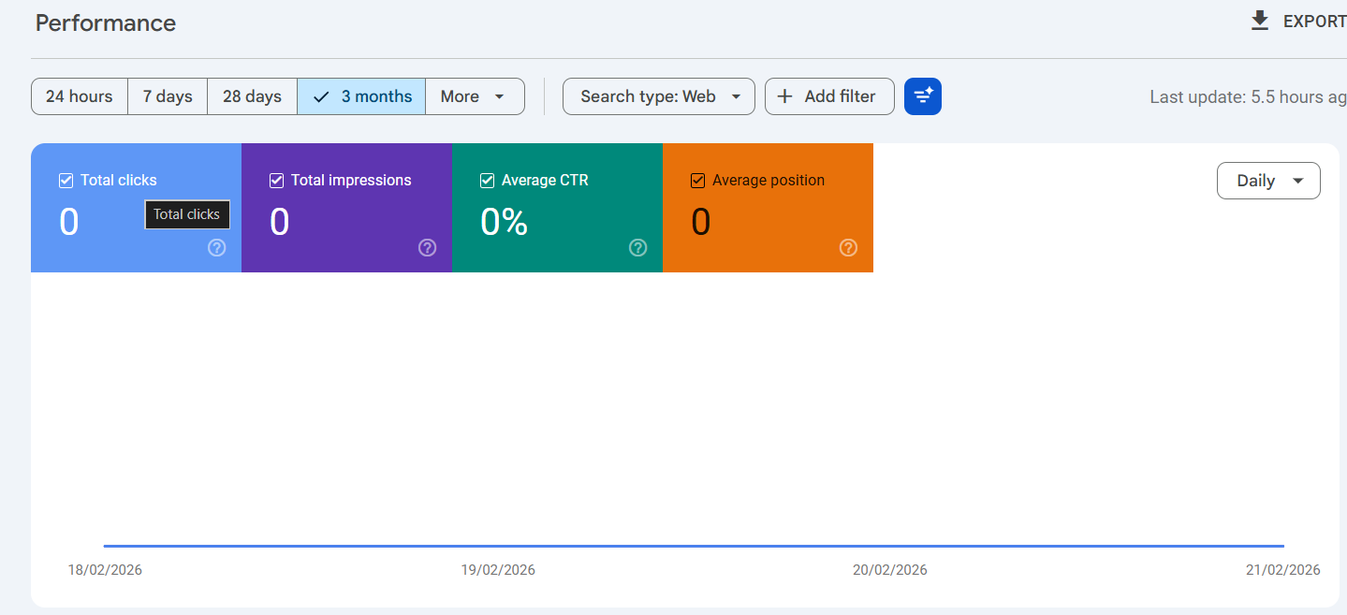

3. Page Indexing Report
The Page Indexing section shows:
- Indexed Pages: 6
- Not Indexed Pages: 13
- Total Pages: 19
Analysis:
Most pages are not indexed. This means Google is not showing many pages in search results.

Possible reasons:
- Sitemap not submitted.
- New website.
- Low content quality.
- Internal linking issues.
Recommendation:
- Submit sitemap.
- Request indexing for important pages.
- Improve content quality.

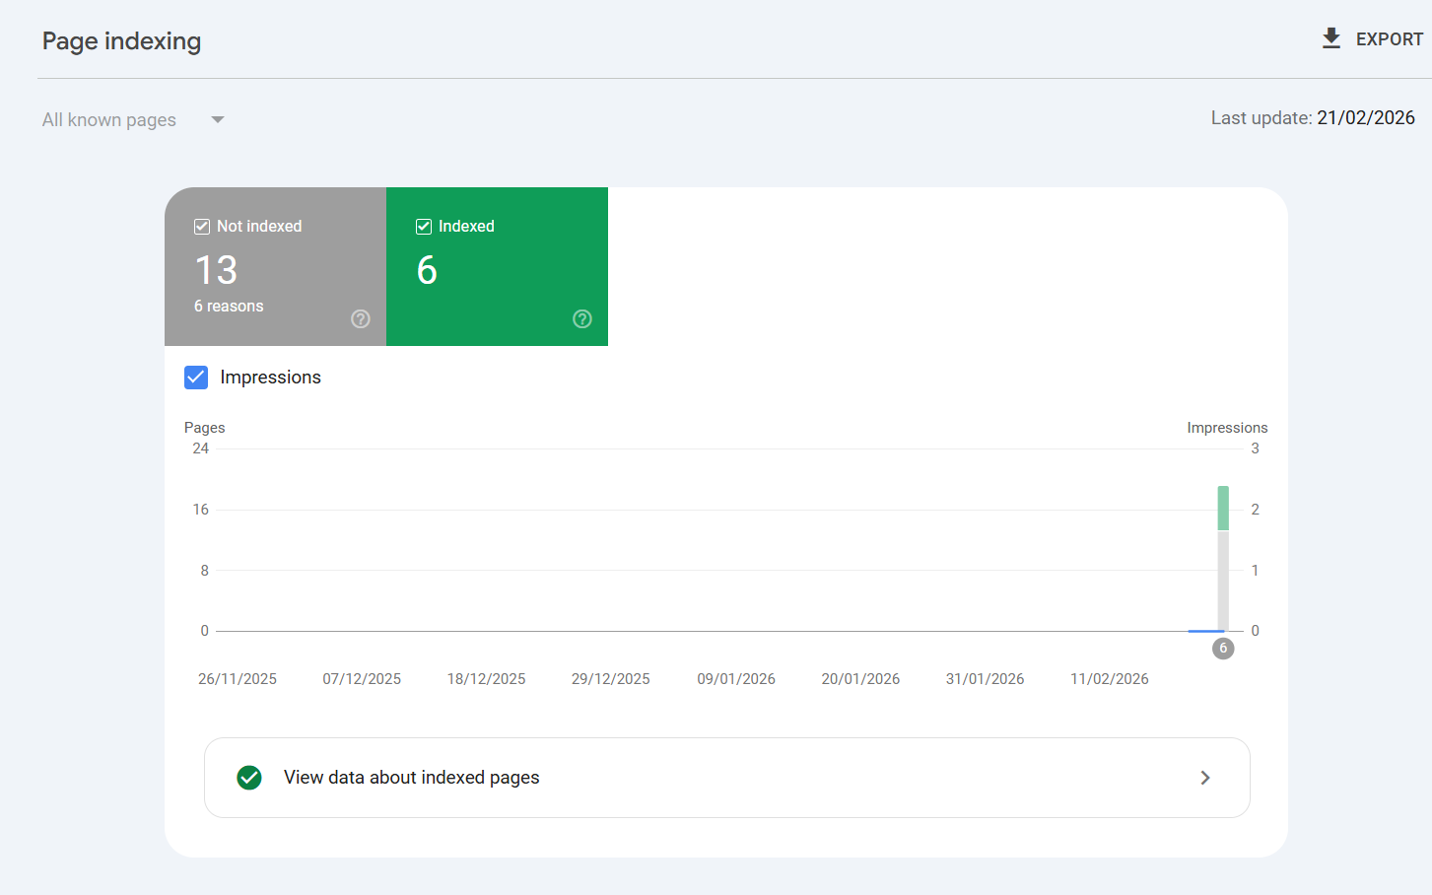

4. URL Inspection Report
The URL Inspection tool was used to test:
https://ben10.liveblog365.com/about/
Result:
- URL is available to Google.
- Page can be indexed.
- Breadcrumb structured data detected.
Interpretation:
The page has no major technical errors and is eligible for indexing.

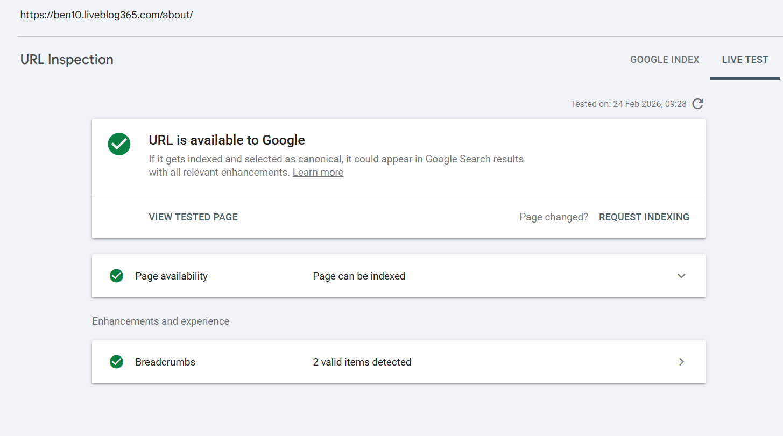

5. Sitemap Report
The Sitemap section shows:
- No sitemap submitted
Problem:
Without sitemap submission, Google may take longer to discover pages.
Recommended Sitemap:
https://ben10.liveblog365.com/sitemap.xml
Action Required:
- Generate sitemap.
- Submit sitemap in Google Search Console.
- Monitor indexing improvements.

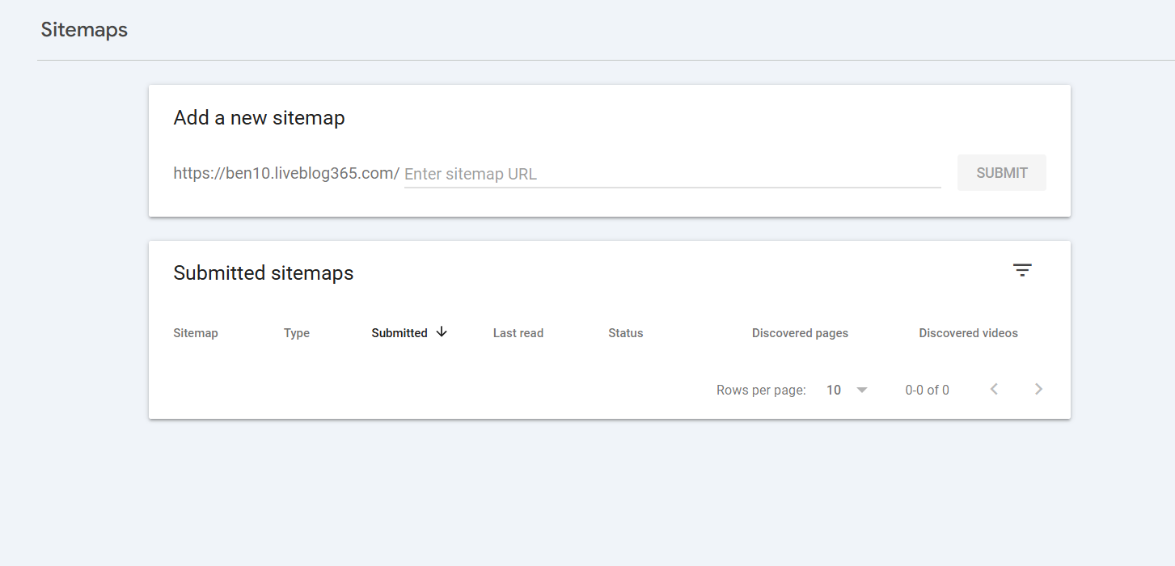

6. Core Web Vitals Report
The Core Web Vitals report shows:
- Not enough data in the last 90 days.
Meaning:
The website does not have enough traffic for Google to measure real-user performance data.
Suggested Improvements:
- Optimize images.
- Enable caching.
- Reduce unnecessary scripts.
- Improve page speed.

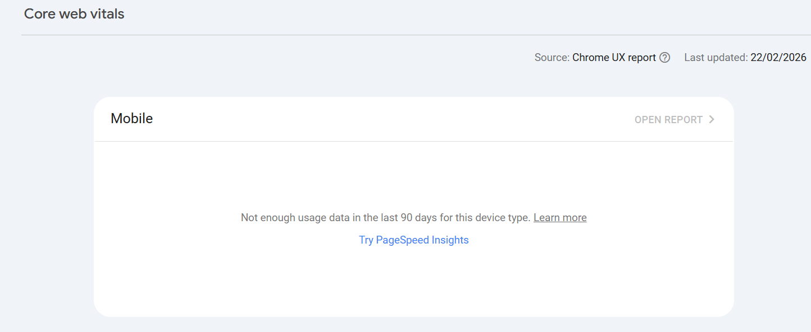

7. Issues Identified
- Low indexing rate.
- No search traffic yet.
- Sitemap not submitted.
- Website still in early stage.

8. Conclusion
The website is technically accessible to Google but still in the early development stage.
This website is still in developing stage .
So Sitemaps are not submitted yet, Pages are not Indexed.

Submitted by:
Shameel Abdul Jabbar

